3RD BDE OPORD 24-04 Ranger Buddy Challenge (RBC)

References:
a. USAIS PAM 350-6, 16 DEC 2022
b. MOI 28th Annual Ranger Buddy Competition

Time Zone Used Throughout the OPORD: Romeo (R) (Central Daylight Time)

Task Organization:

3RD ROTC Brigade

The University of Kansas Army ROTC (+)
Kansas State University
University of Missouri Kansas City

1. Situation

- Area of Interest.
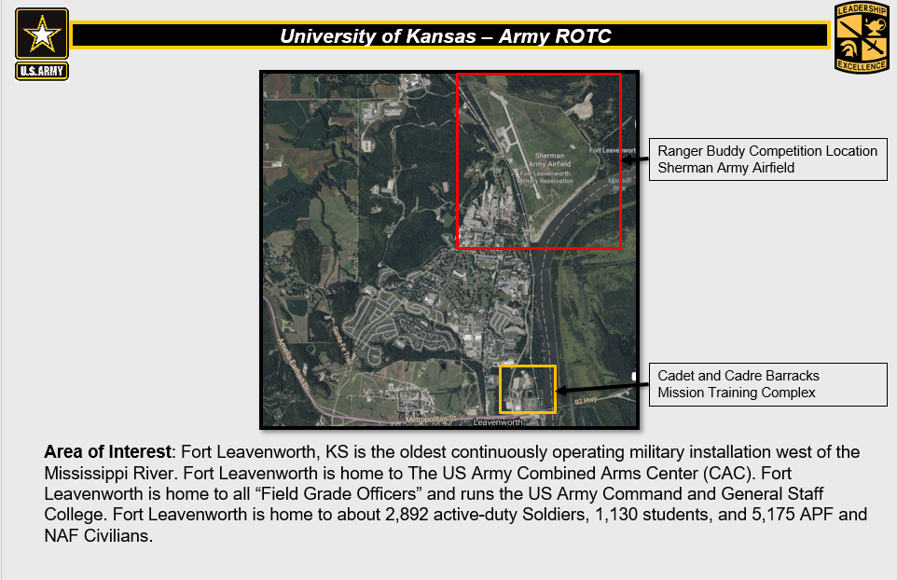

- Area of Operations (AO).
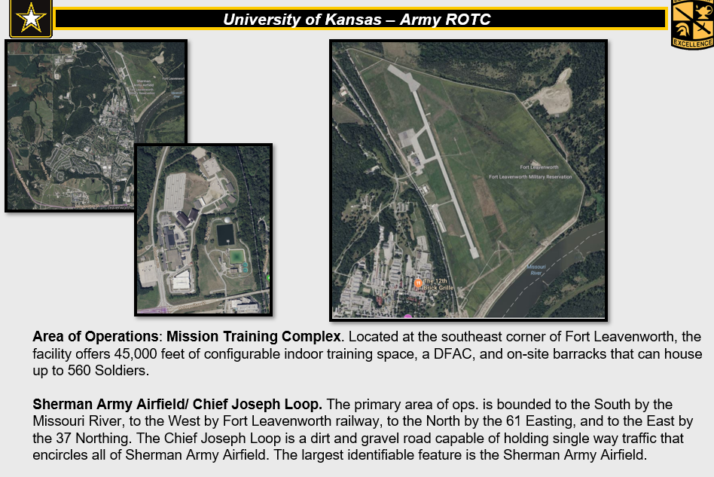

- Terrain.

Avenues of Approach: The primary avenue of approach is McClellan Ave. McClellan Avenue is an asphalt road that facilitates two-way traffic. McClellan Ave. runs parallel to the Ranger Buddy Training site. Chief Joseph Loop encircles the training area. Chief Joseph Loop is a hard packed gravel road. It will facilitate one-way traffic but will be closed off during the competition.

Obstacles: Parallel to Chief Joseph Loop and to the west of the training site is a railway. The rail crossing is the only entry to the Ranger Buddy Competition area. This crossing does not have a functioning gate and is trafficked regularly by trains.

(2) Weather. RBC is an outdoor event. The weather in the Lawrence area during the first week of April is historically mild with a chance of rain. The historic average high is 63°F with the average historic low of 41°F.

c. Enemy Forces. N/A

d. Friendly Forces. N/A

f. Civil Considerations.
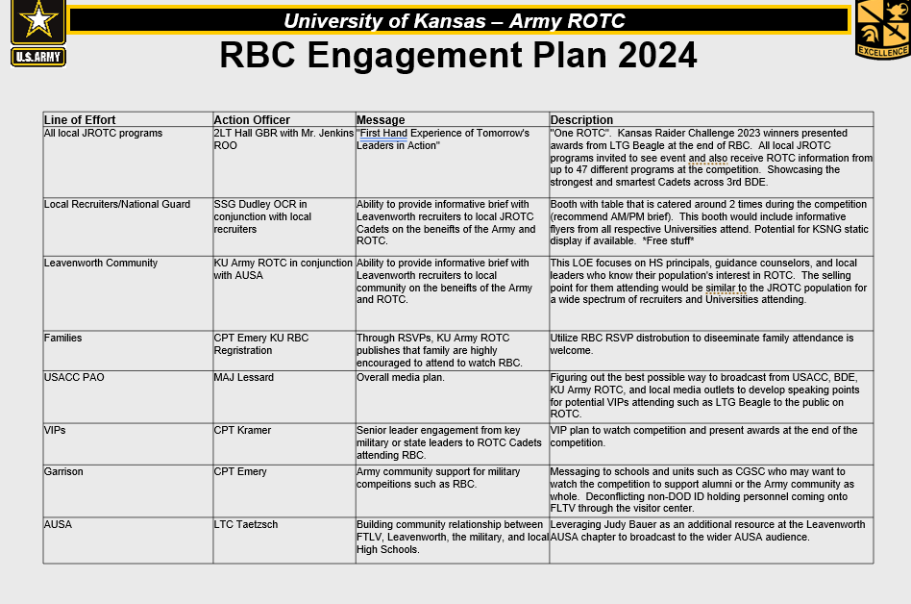

2. Mission. 3RD Brigade conducts Ranger Buddy Competition, under the direction of the University of Kansas, Jayhawk Battalion, at Fort Leavenworth, KS from 060700-1830APR24 to instill a culture of winning and excellence across Cadet Command while maximizing the event as an ROTC marketing opportunity.

3. Execution.

  - Commander’s Intent. Safely conduct a rigorous competition to test Cadet critical thinking, physical endurance, mental toughness, and teamwork while marketing ROTC opportunities for future competitors.

(1) Key Tasks:

  - Complete tactical tasks aligned with CC policy letter 9 to build proficiency prior to CST 24.

  - Maximize participation of all Cadets by fielding teams across as many categories as possible.

  - Market opportunities outside of ROTC to grow this competition and other ROTC events.

  - Compete and win.
(2) End State: Cadets safely conduct RBC and recognized for their achievements. Positive experience for all competitors and competing schools.

  - Concept of Operations. This operation is conducted in three phases. Phase I- RSOI, Phase II- Execution, Phase III- Awards Ceremony and Dismissal. Decisive to this operation is execution of warrior tasks during PH II. This is decisive because it will carry the most weight for competing teams in the competition.

    - PH I- RSOI- Critical to this phase is the reception of all competitors at Fort Leavenworth, KS NLT 051800APR24. Prior to the reception of competitors all teams must register at Link. Competitors and coaches are invited to attend IPR’s held by KU starting on 01MAR24.

    - PH II- Execution- Critical to this phase is the execution of tactical lane tasks. This phase begins with a written land navigation exam on 05APR and ends with the completion of tactical lanes on 06APR. During this phase competitors will complete 15 tactical tasks and a series of road marches that equal around 13.5-miles.

    - Ph III- Award/Recovery- This phase begins o/a 061800APR24 after the completion of tactical tasks and road march events. Critical to this phase is the recognition and awarding of best Ranger Buddy teams.

  - Scheme of Movement and Maneuver

(1) Phase 1-RSOI: This phase begins with the receipt of this OPORD. Critical to this phase is the reception of all Cadets at Fort Leavenworth, KS. During this phase all Cadets will register, schools will attend In progress reviews (IPRs), KU will lead rehearsals, resourcing of events, and all in-processing is complete. This phase ends when teams have received the coaches brief.

        - Registration: The registration window opens on 15FEB24. During this phase ROTC Battalions register their teams through the attached website. Registration closes on 14MAR24. Schools may register up to 8 teams for the competition. Schools within 3RD BDE are guaranteed that they will receive 4 competition teams for the event. Schools will provide OML number with team entry and we will prioritize team selection by OML until we have 180 teams registered for the event. We will announce the selection of teams on 15MAR24 during the IPR.

        - IPRs: KU hosts a series of IPRs to facilitate questions and logistics prior to the execution of Ranger Buddy. IPRs take place on 01MAR24, 15MAR24, and 29MAR24. Everyone is welcome to attend the IPRs. IPRs will be held on the KU Teams channel at KU Ranger Buddy Competition.

        - Rehearsals: KU leads the execution of rehearsals leading up to Ranger Buddy Competition. KU executes Rehearsal of Concept drill on 28MAR24, event will be broadcast on MS Teams. Lane Rehearsal is conducted on 04APR24 with KSU and UMKC present. Train the Trainer and station preparation is executed on 05APR24 with TF Leavenworth Cadre. Comms Rehearsal takes place 06 0630 APR 24.

        - Resourcing: Occurs throughout this phase. All resourcing requests are run through KU Supply and passed through BDE S4. All resource requests must be submitted NLT 01MAR24. Teams are provided barracks at Fort Leavenworth, KS. There is no need to resource outside lodging.

        - In-Processing: The final list of teams is published to all schools on 15MAR24. All requests for changes must be made and approved through KU operations officer, CPT Emery, following this date. Teams arrive to Fort Leavenworth Mission Training Complex NLT 05 1750 APR 24. Teams receive packets and room assignments upon arrival to the barracks.

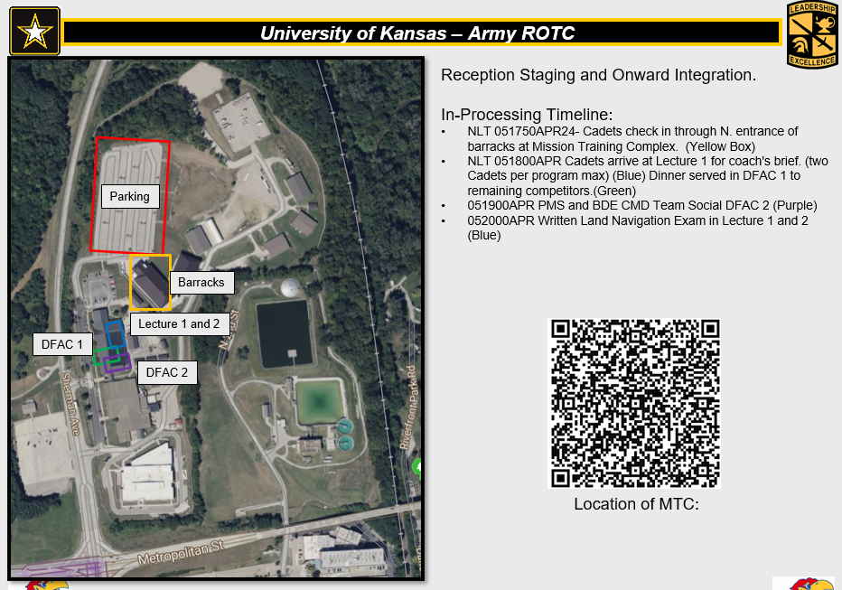

        - Coaches Brief: 06 1800 APR 24 Cadets will receive a coaches brief in lecture 1 of the mission training complex. Only one representative from each school is required to be at this meeting. During the coaches’ brief, dinner will be served in DFAC 1.

        - BDE Social: Cadre attending the event will have the opportunity to meet with COL Cruz. All 3RD BDE Cadre will attend the BDE Social in DFAC 06 1900-2000 APR 24.

(2) Phase 2- Execution: This phase begins following the coaches brief on 05APR24 and ends when all teams have finished their final iteration of lanes or road march on 06APR24. Critical to this phase is the execution of tactical lane tasks. During this phase competitors will complete 15 tactical tasks and a 13.5-mile road march. Each competitor will be assigned a control group. Each control group will start at different areas of the course. Competitors will undergo three iterations of the lanes (red, white, and blue). At each lane, competitors complete 5 tactical tasks, and a 4.5 mile road march.

a. Written Land Navigation: Following the coaches briefs competitors will have 1 hour to answer as many questions as possible on a written land navigation exam. This exam will replicate the ones given at Cadet Summer Training- Advanced Camp. This event will account for 10% of the overall ranking of the competition.

              - Tactical Lanes: Decisive to competitors’ operations is the successful execution of the 15 tactical tasks. This is decisive because it holds the most weight in the competition. 50% of Cadets scores are based on the correct completion of each tactical task. The tactical tasks are governed by EIB Pamphlet 350-6, 16DEC22. Reference Attachment. Knots are governed by TC 3-21.76 Ranger Handbook, while testing standards are from Army Mountain Warfare VT 05465-9796 (Time Standards).

Red
Task | Task # | Time Standard
M4 | 071-100-0032  071-100-0029 | 5
M249 | 071-com-4025  071-Com-4026 | 6
M240 | 071-COM-4025  071-COM-4026 | 6
Hand Grenades | 071-440-0031  071-COM-4407 | 4

White
Task | Task # | Time Standard
Fracture | 081-831-1034 | 5
Bleeding | 081-com-1001  081-000-0048  081-000-0099 | 5
Shock | 081-com-1005  No Collar Required | 9
Care Under Fire | 081-COM-1001  081-COM-1048  081-COM-1046 | 9
9 Line | 131-COM-1001  081-COM-0101 | 2

Blue
Task | Task # | Time Standard
Call for fire | 061-COM-1000  071-326-9512 | 5
Radio and Spot | 171-300-0063  171-COM-4080 | 10
Knots | TC 3-21.76 | 3
Move under fire | 071-COM-0502 | 3

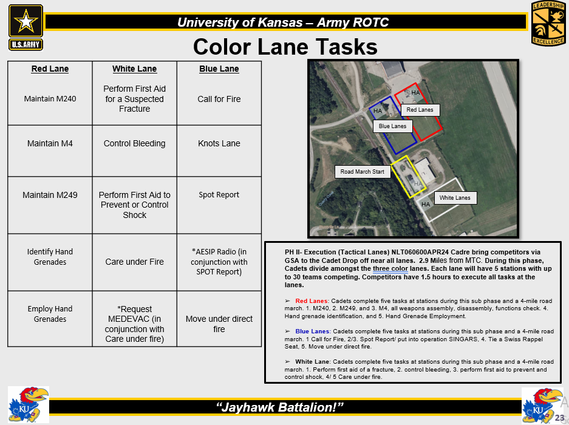

c. Road March: The road march event occurs at the same time as the tactical lane event. Cadets are assigned either to the lane or to complete the 4.5-mile loop for the road march course. In total, Cadets will travel this route 3 times. On the final iteration, Cadets will receive additional equipment to carry with them on the course.

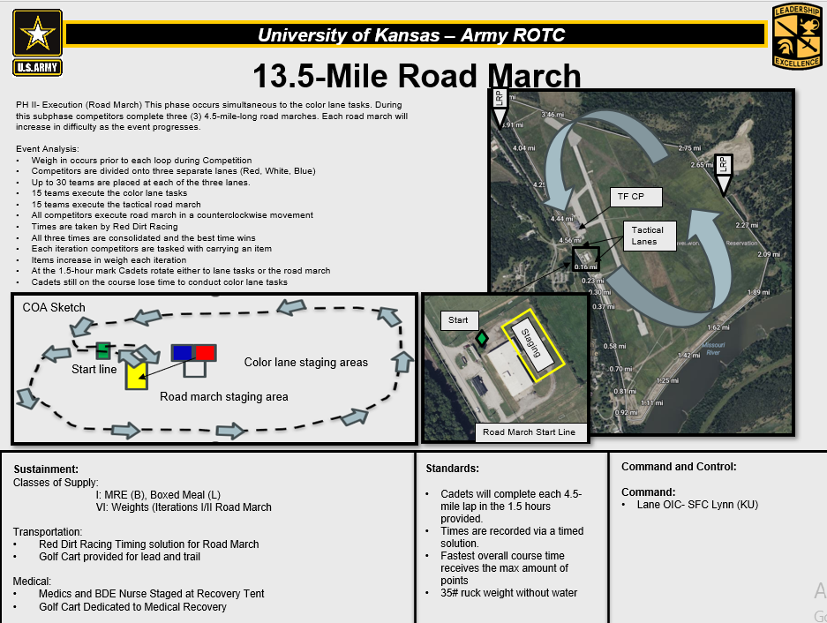

(5) Phase 3- Awards Ceremony, Recovery, Release: This phase begins after all personnel have completed the last iteration of road march or tactical lanes. During this phase, distinguished quests are allowed to make remarks. Following remarks, COL Cruz, 3RD BDE Commander, will award the top 3 teams from each category and the top school. Schools are dismissed upon completion of the ceremony to return to the barracks or return to their host schools.

  - Tasks to Staff.

(a) BDE S3

(1) Establish the BDE IPR through MS teams in accordance with IPR schedule to validate planning azimuth, resource shortfalls, and provide brigade assistance.

(2) Provide one staff representative to assist operations in Task Force TOC.

(b) BDE S4

(1) Provide one member of staff to attend IPR’s and assist with resourcing the training event.

(2) Process PRAs submitted from program.

(3) Provide one staff representative to assist with local purchases during week of event.

(c) BDE Nurses

    - Provide a Nurse to serve in the TOC and establish and run a casualty collection point (CCP).

    - Coordinate with KU and BDE S4 to request CL VIII to support the competition.

(d) BDE RMID

(1) Provide one staff representative to assist with social media posts.

c. Tasks to Subordinate Units.

(a) The University of Kansas

(1) Plan and execute RBC in conjunction with the 3RD BDE.

(b) University of Missouri Kansas City and Missouri West

(1) Provide 1 Cadre OIC and 12 x Cadets or Cadre to run Red Lanes for the event.

(2) Coordinate for supply with the University of Kanas during IPR’s.

    - Attend lane Rehearsals on 04APR24

    - Provide 20 each 40# kettlebells for the competition.

(c) Kansas State University

(1) Provide 1 Cadre OIC and 12 x Cadets or Cadre to run Blue Lanes for the event.

(2) Coordinate for supply with the University of Kanas during IPR’s.

    - Attend lane Rehearsals on 04APR24

    - Provide 20 each 40# kettlebells for the competition.

(d) Task Force Leavenworth

(1) Provide one (1) Cadre to assist with grading if you have any teams participating in the competition. Provide one (1) additional cadre for any number of teams over four (4).

(e) Participating Schools

(1) All CADRE complete DTS authorization NLT 01MAR24, to include lodging after the competition.

(2) Submit travel meal requests on PRA to BDE S4 NLT 01MAR24. A POC and contact information from the vendor must be included.

    - Register your teams at the link. Ensure teams are entered on an OML for you school from 1 to 8. Cadets with a 1-4 are guaranteed to compete. Cadets 5-8 will be selected in OML order starting with OML number 5.

d. Coordinating Instructions.

- Uniform:

- Worn:
  - OCP top/ bottom (duty uniform)
  - Patrol Cap (Cover)
  - Boots
  - Eye protection
  - Gloves
  - FLC- (2x 1 QT Canteens)
  - Rubber Duck
  - Ruck Sack
  - Pen, Pencil, Paper
  - MRE (breakfast day 1) (KU will not inventory this item)

- Rucksack: Must weigh 35 pounds excluding drinking water.

- Rucksack is worn during the Ruck March. Cadets will not wear rucksacks on tactical lanes. Competitors must carry their own equipment. Teams are disqualified if caught carrying their teammate’s equipment or out of prescribed uniform. Rucksacks are inspected prior to and after execution of each iteration of ruck march.

- Timeline:

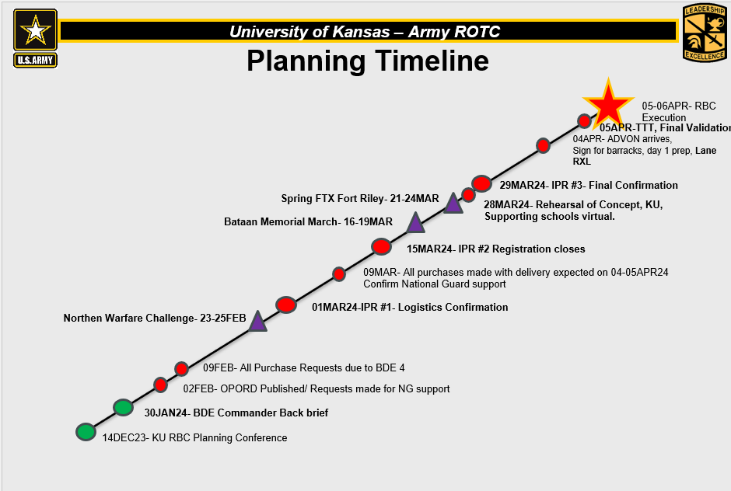

- Event Schedule: See MOI (para 3)

(c) Rules: See MOI (para 5)

- Participants register NLT 01APR24. Link: https://docs.google.com/forms/d/1SmOMOnxSuFCAQg2Fjq8l8pSHmA5JhyBkTWCSpKLDxuE/edit

- Engagement Plan:
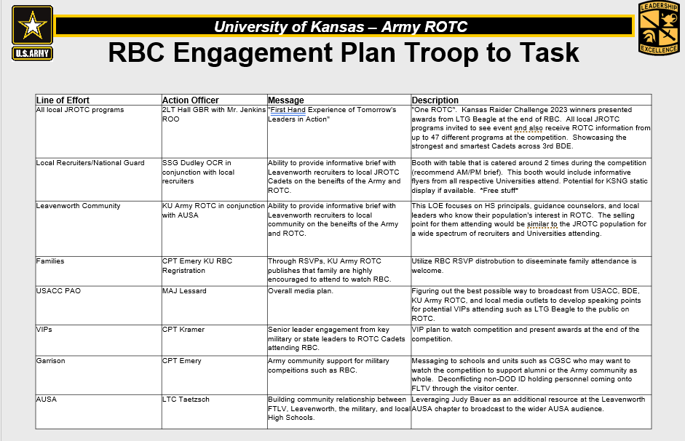

- Risk Mitigation: See attachment Deliberate Risk Assessment:

4. Sustainment.

a. Logistics.

(1) Classes of Supply.

      - Class 1: Schools will coordinate for and/ or supply meals traveling to and from the event. Schools will bring 1 MRE for each competitor for breakfast on 06APR24.

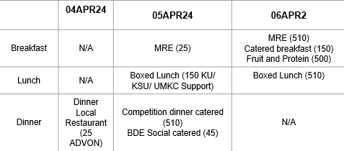

(2) Transportation/Lodging. Host school provides GSA for transportation to/during RBC. No POV’s are authorized or allowed on the Ranger Buddy Competition Course. 3RD BDE will fund lodging for personnel departing after the competition, lodging must be coordinated prior to the event. Cadet lodging will be paid for by GUTC, a PRA will be provided to the BDE S4 NLT 01MAR24 and CADRE will create DTS authorizations NLT 01MAR24.

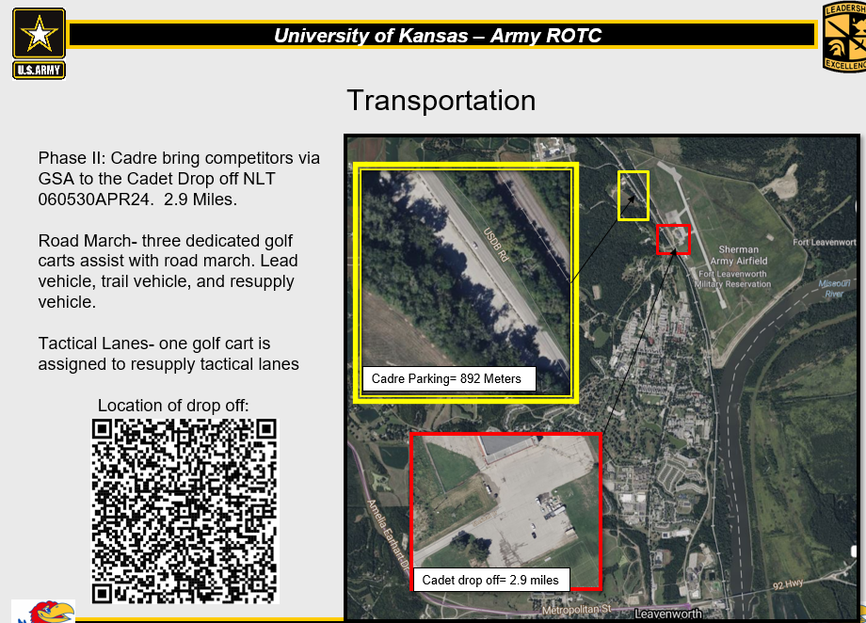

              - Lodging: Lodging is provided for all competitors. Competitors will be housed at the Mission Training Complex at Fort Leavenworth, KS. Teams must select during registration whether they will stay in the provided lodging. Lodging includes bunk bed style accommodations, showers, latrines, and lockers.

c. Personnel support. None.

d. Health System Support. Medical Treatment: Medics and BDE Nurse are located at CP, Medic will be dispatched to provide aid for non-life-threatening injuries if necessary. Medical Evacuation: Casualty Collection Points (CCP) is located at CP. For medical emergencies call 911. If non-life threatening, a CASEVAC to Saint Johns hospital.
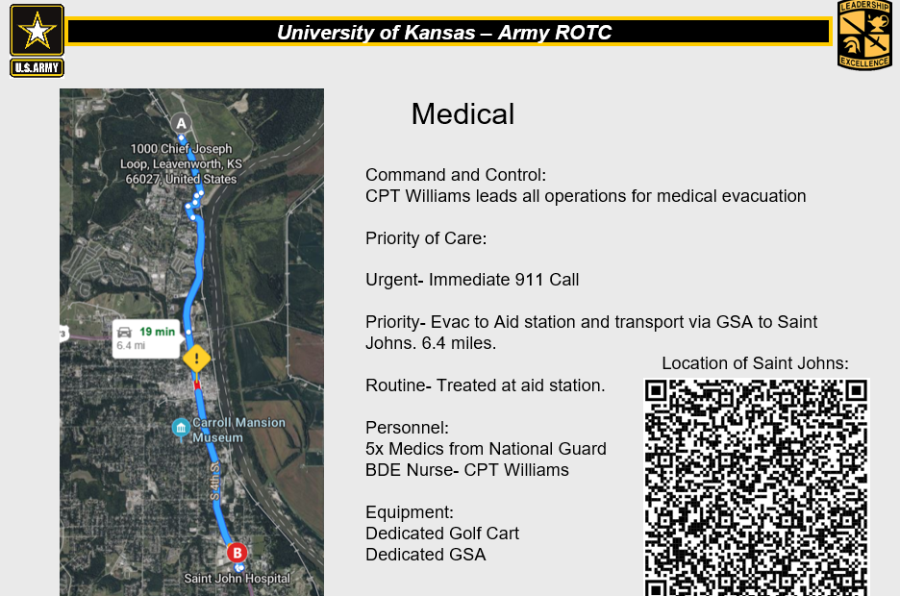
5. Command and Signal.

a. Command.

- Location of Commander. The PMS of the University of Kansas is located in the CP.

- Succession of Command.

  - The OIC for Ranger Buddy Challenge is CPT Travis J. Emery at travis.emery@KU.edu or at 801-735-4553.

  - The NCOIC for Ranger Buddy Challenge is MSG Josh Geery at joshua.d.geery@ku.edu or at 785-864-1111.

b. Control.

(1) Control Posts. N/A

(2) Reports (formats and times for submission). Primary reporting for the event will be via the Signal chat. TBP This will be the primary location for periodic score updates.

(3) RFI’s during the competition will be submitted through separate RBC signal chat.

RFI Group Chat

c. Signal.

- Primary POC for this ORDER is CPT Travis J. Emery at travis.emery@ku.edu or at 801-735-4553

- Reference ANNEX C

- Primary means of communication. Signal Group Chat

- Alternate. Cell Phone

- Contingency. Handheld radios

(4) Emergency. Runner

ACKNOWLEDGE:

CRUZ
COL

OFFICIAL:
JENKINS
MAJ

ANNEXES:
ATTACHMENT 1: EIB Pamphlet 350-6, 16DEC22
ATTACHMENT 2: RBC MOI
ATTACHMENT 3: RBC TASKS
ATTACHMENT 4: DELIBERATE RISK ASSESSMENT
ANNEX C: Concept of Operations Brief Slide Deck

